ASP.NET Core Web Api

What is Web API?

Api – Application Programming Interface

Web api is a concept (not a technology) that works on HTTP protocol, and it is used to extend the functionality of an application.

REST:

Rest – Representation state transfer

REST is a combination of couple of principles that must be followed by the web api.

* URL structure: URL of application must follow the REST principle.
* HTTP Verbs
* Status code
* Stateless

What is HTTP?

* HTTP – Hyper Text Transfer Protocol
* HTTP is used for the communication between client and the web server.

Request

WWW web server

Response

Client server

HTTP is an application layer protocol for distributed, collaborative, hypermedia information systems.

HTTP Request and its components:

When we send something from our client to the server or a browser to the Web Server, then that is called as Request.

Components:

* URL
* Verb (method)
* Header
* Body
* Data

HTTP Response:

Whatever we get from our Web server to the client that is called as response.

Components:

* Status Code
* Response Header or Multiple Header
* Response will also have some data.

HTTP Verbs:

**GET:**

* Thet Get method is used to retrieve data.
* Example – Get the book data, search a book, etc.

**Post:**

* The Post method is used to make a new entry in database.
* Example – Add a new book, Add new employee etc.

**PUT:**

* The put method is used to upload all the properties of current resource in the database.
* Example: Update all properties of an existing resource.

**Patch:**

* The Patch method is like PUT but it is used to update partial properties of current resource in the database.
* Example – Update few properties of an existing resource.

**Delete:**

* The DELETE method is used to delete the resource from the database.
* Example- Delete an existing resource from database.

STATUS CODE:

* Status codes are issued from the server, and they give the information about the responses.
* All HTTP response status code is divided into five categories.
* 1xx- Information response
* 2xx- Successful
* 3xx- Redirection
* 4xx- Client error
* 5xx- Server error

Frequently used Status Code

* **200** OK
* **201** New Resource created.
* **204** No content (The server processed the request successfully and it is not returning any content)
* **301** Moved permanently.
* **302** Moved temporary.
* **400** Bad Request
* **401** Unauthorized
* **404** Not Found
* **405** Method not allowed.
* **500** Internal server error
* **503** Service unavailable

**Command for checking dotnet is install in your machine or not:**

Open command prompt and type: dotnet

**Command for checking version of dotnet:** dotnet --info

Create first Web API project:

Open visual studio🡪 Create new project -> select Asp.net core web api -> create project

Files:

1. launchSettings.json file:

* launchSettings.json file is a configuration file used to configure various aspects of how our application should be launched and debugged during development. This file is typically found in the “Properties” folder.
* The settings within the LaunchSettings.json file will be used when we run or launch the ASP.NET core application.
* The most important point you need to remember is that this launchSettings.json file is only used within the local development machine.

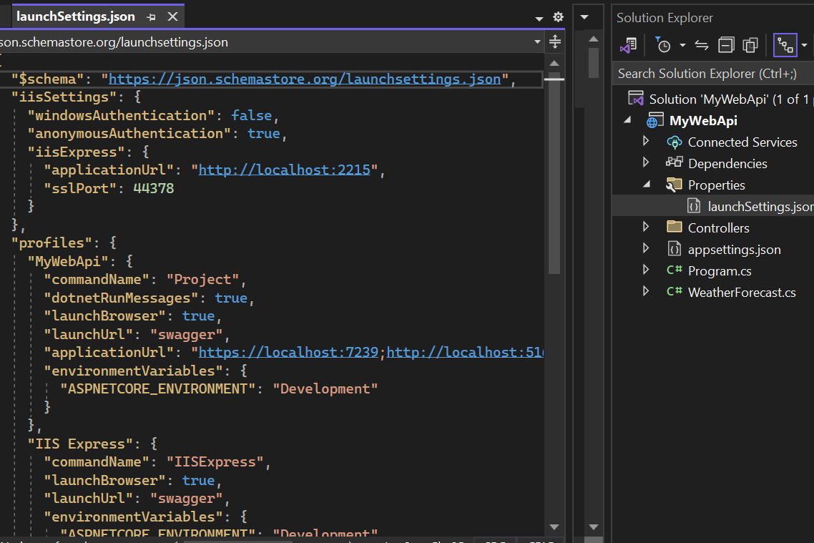

What is Swagger?

* Swagger is used to describe Restful APIs.
* Swagger allows developers to create interactive and human-readable API documentation.
* Swagger is used to test APIs.

>>>>>>>>Controller file >>>>>>>>>>>>>>

What is ControllerBase?

* The ControllerBase class is base class for controllers in ASP.NET core that handles HTTP requests.
* It provides a set of common properties and methods controllers use to handle HTTP requests and generates HTTP responses.

Ex: [ApiController]

[Route("[controller]")]

public class WeatherForecastController:ControllerBase

{

private static readonly string[] Summaries = new[]

{

"Freezing", "Bracing", "Chilly", "Cool", "Mild", "Warm", "Balmy", "Hot", "Sweltering", "Scorching"

};

What is [ApiController] attribute?

* The [ApiController] attribute enables a few features including attribute routing requirements, automatic model validation and binding source parameter inference.